

**DOMBIVLI SHIKSHAN PRASARAK MANDAL’S**

**K.V. PENDHARKAR COLLEGE OF**

**ARTS, SCIENCE AND COMMERCE (AUTONOMOUS)**

**DOMBIVLI (E)-421203**

**A PROJECT REPORT ON**

*“Spam Detection System”*

**DEVELOPED BY:**

DISHANK VIJAY RANE

THIRD YEAR OF COMPUTER SCIENCE

**UNDER THE GUIDANCE OF**

**PROF.SMITA SONAWANE**

**SUBMITTED TO**

**UNIVERSITY OF MUMBAI**

**2023-2024**



**CERTIFICATE**

**THIS IS TO CERTIFY THE FOLLOWING STUDENT HAVE SUCCESSFULLY COMPLETED THE PROJECT OF**

**Spam Detection System**

**AS PER THE SYLLABUS AND THAT IT FORMS A PART OF THE REQUIREMENTS FOR COMPLETING THE BSC DEGREE IN COMPUTER SCIENCE**

**ACADEMIC YEAR 2023-2024**

**NAME OF STUDENT: DISHANK VIJAY RANE**

**ROLL NO: 234802**

**UNDER THE GUIDANCE OF**

**PROF.SMITA SONAWANE**

**Project Guide Head of Department Examiner**

**(Prof. Smita Sonawane) Computer Science**

**Date: -**

ACKNOWLEDGEMENT

IT IS MATTER OF GREAT PLEASURE AND PROUD PRIVILEGE TO BE ABLE TO PRESENT THIS PROJECT ON “Spam Detection System”.

THE COMPLETION OF THE PROJECT WORK IS A MILESTONE IN STUDENT LIFE AND ITS EXECUTION IS INEVITABLE IN THE HANDS OF GUIDE. I AM HIGHLY INDEBTED THE PROJECT GUIDES PROF.MRS. SMITA SONAWANE. HER INVALUABLE GUIDANCE AND APPRECIATION FOR GIVING FORM AND SUBSTANCE TO THIS REPORT. IT IS DUE TO HER ENDURING EFFORTS, PATIENCE AND ENTHUSIASM, WHICH HAS GIVEN A SENSE OF DIRECTION AND PURPOSEFULNESS TO THIS PROJECT AND ULTIMATELY MADE IT SUCCESS.

I WOULD LIKE TO TENDER OUR SINCERE THANKS TO ALL THE H.O.D.

PROF. MRS. SMITA SONAWANE AND ALL THE TEACHERS FOR THEIR COOPERATION. I WOULD LIKE TO EXPRESS MY SINCERE THANKS TO MY FRIENDS.

I WOULD LIKE TO EXPRESS OUR DEEP REGARDS AND GRATITUDE TO THE PRINCIPAL DR. K.R. JAGDEO**.**

I WOULD LIKE TO THANK TO NON-TEACHING STAFF AND MY FRIENDS WHO HAVE HELPED ME ALL THE TIME IN ONE WAY OR THE OTHER.

**DECLARATION**

I hereby declare that the project work entitled “Spam Detection System” submitted to,

the D.S.P.M’S K .V. PENDHARKAR COLLEGE, is a record of an original

work done by me, under the guidance of Prof. Mrs. SMITA SONAWANE

Dept. Of Computer Science, and this project work is submitted in the partial

fulfilment of the requirements for the award of the degree of Computer

Science. The results embodied in this thesis have not been submitted to any

Other University or Institute for the award of any degree.

**INDEX**

|  |  |  |
| --- | --- | --- |
| **Sr.No** | **Description** | **Page No** |
| 1. | **Introduction**   * 1. Introduction   2. Objective   3. Purpose   4. Scope | 6 |
| 2. | **Literature Review**   * 1. Existing System (Previous History)   2. Drawbacks of Existing System | 8 |
| 3. | **Requirement Specification**   * 1. Problem Definition   2. Requirement Specification   3. Planning and Scheduling   4. Software and Hardware Requirement   5. Preliminary Product Description   6. Conceptual Models | 9 |
| 4. | **System Design Details**   * 1. Water-Fall Model   2. System Architecture Diagram   3. Activity Diagram   4. Class Diagram   5. Use case Diagram   6. Data Flow Diagram   7. Database Structure   8. Languages & Tools Used | 13 |
| 5. | **Code Implementation** | 19 |
| 6. | **System Design Details**   * 1. Test Cases   2. Screenshots | 20 |
| 7. | **Conclusion and Future Scope** | 21 |
| 8. | **References** | 23 |

**Chapter 1: Introduction**

Welcome to the forefront of digital communication security with our innovative SMS Spam Detection System. This cutting-edge solution is engineered using the latest in machine learning algorithms and data analysis techniques, offering an unparalleled shield against the ever-evolving threat of unwanted messages. Our system delves deep into the intricacies of SMS content, employing a sophisticated blend of natural language processing and statistical analysis to discern between genuine communication and spam.

Embark on a journey with us as we navigate through the complexities of data preprocessing, feature engineering, and model selection, all tailored to enhance the precision and efficiency of spam detection. Our platform is not just a tool but a guardian, designed to adapt and learn from new patterns in spam messages, ensuring your digital space remains secure and uninterrupted.

With our SMS Spam Detection System, experience peace of mind as we elevate the standard for secure messaging. Step into a world where each message is meticulously scanned, and only the relevant ones make their way to your inbox, making spam messages a thing of the past.

**1.1 Objective:**

The primary objective of this project is to develop a highly efficient and accurate SMS spam detection system. Leveraging advanced machine learning algorithms, the system aims to automatically classify incoming SMS messages as either 'spam' or 'ham' (non-spam), thereby protecting users from unsolicited and potentially harmful content.

**1.2 Purpose:**

The purpose of this project is to enhance the user experience by ensuring the security and integrity of SMS communication. By filtering out spam messages, the system not only safeguards users' personal information but also significantly improves the relevance and quality of the messages they receive.

**1.3 Scope:**

The scope of the project encompasses the following key areas:

* Collection and preprocessing of a comprehensive dataset of SMS messages, including both spam and ham classifications.
* Implementation and fine-tuning of machine learning models to achieve optimal classification accuracy.
* Evaluation of model performance using standard metrics such as precision, recall, and F1 score.
* Deployment of the trained model into a user-friendly application, allowing for real-time spam detection.

**1.4 Description:**

This project entails the development of a sophisticated SMS spam detection system using cutting-edge machine learning techniques. It involves a thorough analysis of SMS data, preprocessing steps such as tokenization and removal of stop words, and the application of algorithms like Naive Bayes, Support Vector Machine (SVM), and Random Forests for classification. The system is designed to be adaptable, learning from new spam trends to maintain high accuracy over time.

**1.5 Key Features of SDS:**

* Real-Time Detection: Instant classification of incoming SMS messages as spam or ham, providing immediate protection against spam.
* High Accuracy: Utilization of advanced machine learning algorithms ensures a high degree of accuracy in spam detection.
* User Privacy: Designed with a strong emphasis on user privacy, ensuring that message content is processed securely.
* Adaptability: Ability to learn from new data, adapting to evolving spam techniques and maintaining effectiveness.
* User-Friendly Interface: Easy-to-use interface for end-users, requiring minimal interaction for effective spam protection.

**Chapter 2: Literature Review**

**2.1 Previous History:**

The battle against SMS spam has been ongoing since the inception of text messaging as a communication tool. Early solutions were primarily rule-based, relying on blacklists of known spam numbers and keyword detection to filter out unwanted messages. These systems were straightforward but lacked the sophistication to adapt to the evolving tactics of spammers, who quickly learned to circumvent these measures by altering message content and rotating through different phone numbers.

As technology advanced, machine learning models began to play a pivotal role in spam detection. These models, trained on large datasets of labeled messages, could learn and predict whether an incoming message was spam based on its content and metadata. Techniques such as Naive Bayes, Support Vector Machines, and Decision Trees were employed, offering improved accuracy over rule-based systems by considering the nuanced patterns and features of spam messages.

**2.2 Drawbacks of Existing System:**

Adaptability: Spammers continually refine their strategies to bypass detection systems. Many existing models struggle to adapt to these changes quickly, leading to a lag time during which new types of spam messages can proliferate.

False Positives: A significant drawback of some spam detection systems is the high rate of false positives, where legitimate messages are mistakenly classified as spam. This issue can lead to important messages being missed or delayed, causing inconvenience and potential loss of information.

Data Imbalance: The datasets used to train spam detection models often have an imbalance, with a much larger proportion of legitimate messages compared to spam. This imbalance can lead to models that are biased towards predicting messages as legitimate, potentially allowing more spam messages to slip through.

Privacy Concerns: Some advanced detection systems require deep analysis of message content, which raises privacy concerns. Users may be wary of systems that need to access the content of their messages to determine whether they are spam.

Resource Constraints: Effective spam detection often requires significant computational resources, especially for systems that use more complex machine learning models. This requirement can be a barrier to implementation, particularly for smaller organizations or systems with limited processing capabilities.

**Chapter 3: Requirement Specification**

**3.1 Problem Definition**

The proliferation of unsolicited and often malicious SMS messages poses a significant challenge to digital communication security. The primary problem addressed by this project is the accurate identification and filtering of such spam messages to protect users from potential scams, phishing attempts, and unwanted advertisements. Current solutions either lack the adaptability to keep pace with evolving spam tactics or suffer from high rates of false positives, where legitimate messages are incorrectly classified as spam. This project seeks to develop a more dynamic, efficient, and user-friendly SMS spam detection system that leverages advanced machine learning techniques to improve accuracy, reduce false positives, and adapt to new spam trends.

**3.2 Requirement Specification**

Functional Requirements:

Data Collection and Preprocessing: The system must be able to collect a diverse dataset of SMS messages, preprocess the data by cleaning, tokenizing, and vectorizing the text to prepare it for analysis.

Model Training and Evaluation: Implement and train machine learning models using the preprocessed data, evaluating their performance using metrics such as accuracy, precision, recall, and F1 score to ensure high effectiveness in spam detection.

Real-time Spam Detection: The system should classify incoming SMS messages in real-time, labeling them as 'spam' or 'ham' and taking appropriate action based on the classification.

User Interface: Provide a user-friendly interface that allows users to view and manage detected spam messages, adjust settings, and provide feedback on classification accuracy to improve the system.

Non-Functional Requirements:

Performance: The system must process and classify messages quickly and accurately, with minimal latency to not disrupt the user experience.

Scalability: It should be scalable to handle large volumes of messages and adapt to increasing data sizes as more users utilize the system.

Privacy: Ensure user privacy by implementing secure data handling and processing practices, ensuring that message content is not exposed or misused.

Adaptability: The system must incorporate mechanisms to learn from new spam trends and user feedback, continuously improving its detection accuracy over time.

**3.3 Planning and Scheduling**

The development of the SMS spam detection system followed a structured timeline, beginning with foundational research in November and culminating in rigorous testing by February. This schedule was designed to ensure a methodical approach, allowing for comprehensive development and refinement at each stage.

Research (November):

The project kicked off in November with an intensive research phase. The primary aim during this period was to establish a firm understanding of the problem domain and to set clear, achievable objectives for the SMS spam detection system. I dedicated this time to a thorough exploration of existing literature, spam detection methodologies, and potential datasets for training and testing the models. This foundational work was meticulously documented, providing a strong basis for the subsequent phases of the project.

Documentation (December):

In December, I shifted focus to the documentation phase. Recognizing the importance of a well-documented project plan, I outlined the tasks, milestones, and deadlines critical to the project's success. This documentation included detailed descriptions of the system architecture, design decisions, and dependencies, ensuring clarity and direction for the development phase.

Coding (January):

With the arrival of January, the project moved into the coding phase. This stage was broken down into smaller tasks to enhance manageability and efficiency. Adhering to best practices in software development, I utilized version control systems, maintained coding standards, and conducted regular code reviews to ensure high-quality code. Component testing was integrated into this phase, allowing for early detection and resolution of any issues.

Testing (February):

The final stretch of the project in February was devoted to comprehensive testing. The objective was to validate every facet of the SMS spam detection system, encompassing functionality, performance, security, and user experience. I prepared an extensive set of test cases and procured the necessary data to facilitate effective testing. Emphasis was placed on continuous integration and automation to enhance the efficiency and thoroughness of the testing process, ensuring a robust and reliable system.

**3.4 Software and Hardware Requirement**

Software Requirements

Operating System: Any modern operating system capable of running Python and supporting web technologies (e.g., Windows, macOS, Linux distributions).

Python: Version 3.6 or higher, given its compatibility with most data science libraries and Streamlit.

Streamlit: For creating and deploying the web application interface. Ensure the latest version compatible with your Python installation is used.

Data Science Libraries: Essential libraries including NumPy and pandas for data manipulation, scikit-learn for machine learning algorithms and model evaluation, and nltk for natural language processing.

Web Technologies: Basic knowledge of web technologies (HTML, CSS) might be beneficial for customizing the Streamlit interface, although not strictly required due to Streamlit's high-level functionalities.

Version Control: Git, for version control and collaboration.

Integrated Development Environment (IDE): Any IDE or code editor that supports Python development (e.g., PyCharm, Visual Studio Code, Jupyter Notebooks).

Dependency Management: pip or conda to manage Python libraries and dependencies.

Database (Optional): If persistent storage of data or models is required, a database system compatible with Python (e.g., SQLite, PostgreSQL).

Hardware Requirements

Processor: Multi-core CPU (Intel i5/i7/Ryzen 5/Ryzen 7 or equivalent) for efficient multitasking and computation.

Memory: Minimum of 8GB RAM; 16GB or more is recommended for handling large datasets and intensive computations.

Storage: SSD (Solid State Drive) with at least 20GB of free space for the operating system, software installations, and project files. Additional space may be required for datasets.

Internet Connection: For accessing web-based resources, documentation, Streamlit app deployment, and possible cloud integrations.

Graphics Card (Optional): A dedicated GPU is not required for this project unless deep learning models or extensive data visualizations are employed.

**3.5 Preliminary Product Description:**

SMS Spam Detection System is a user-friendly tool designed to filter out unwanted spam messages from your texts, ensuring that only important messages reach you. Built with Streamlit, a Python-based tool, it offers a simple web interface where users can easily interact with the system. The tool cleans and analyzes messages to determine if they're spam, learning and adapting over time to improve its accuracy. It's equipped with a feedback feature, allowing users to help the system learn and become more effective. Aimed at simplicity and efficiency, this system is your go-to solution for a clutter-free inbox, providing a seamless experience for managing your messages.

**3.6 Conceptual Models:**

Data Preprocessing Model: This model is responsible for preparing the raw SMS data for analysis. It involves cleaning the text by removing unnecessary characters, converting text to lowercase, tokenizing the text into individual words, and removing stop words. This model ensures that the data fed into the machine learning model is clean and standardized.

Feature Extraction Model: After preprocessing, the system employs a feature extraction model to transform the text data into a numerical format that can be understood by machine learning algorithms. Techniques such as Term Frequency-Inverse Document Frequency (TF-IDF) are used to quantify the importance of words within the messages relative to the entire dataset.

Machine Learning Model: At the core of the system lies the machine learning model, which is trained on the preprocessed and transformed data. Various algorithms, such as Naive Bayes, Support Vector Machines, and Decision Trees, are evaluated to determine the most effective approach for distinguishing spam messages from legitimate ones.

Evaluation Model: This conceptual model involves assessing the performance of the machine learning model using metrics such as accuracy, precision, recall, and F1 score. It ensures the model's effectiveness in spam detection and guides further improvements.

User Interaction Model: Integrated within a web application powered by Streamlit, this model defines how users interact with the system. Users can input SMS messages to be classified in real-time, providing an intuitive interface for spam detection.

Feedback and Adaptation Model: This model allows the system to learn from user feedback and adapt to new types of spam messages. It ensures the system remains effective over time by continuously updating the machine learning model based on new data and user inputs.

**Chapter 4: System Design Details**

**4.1 Water-Fall Model**

This Model was proposed by “Winston Royce”. It is also called as a classic life cycle. It suggests systematic sequential approach for software development. Water-Fall model is the absolute first model that is utilized in Software Development Life Cycle (SDLC).

In this model, the result of one phase is the contribution for the following phase. Advancement of the following phase begins just when the past phase is finished. First, requirement gathering is done and the design stage begins and so it goes on with rest of the stages.

**Relative effort for the various activities**

This depicts the relative effort spent on the various activities up to delivery of the system. From this data a very clear trend emerges, the so-called 40-20-40 rule: 40% of the effort is spent on actually programming (coding) the system, while the preceding phases (requirements engineering and design) consume 20% and testing each contain 40% of the total effort.

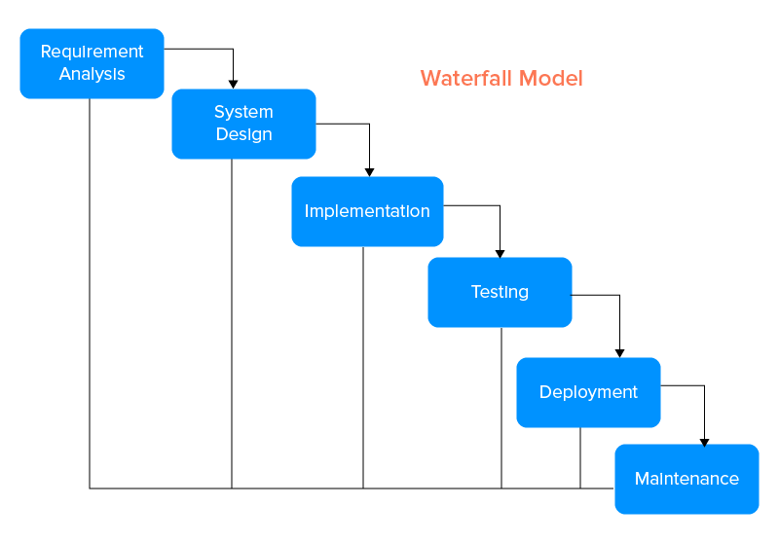

**4.2 System Architecture Diagram**

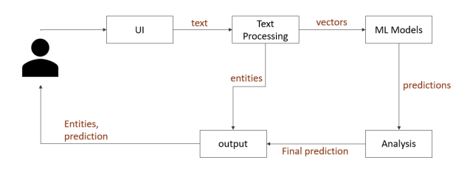

**4.3 Activity Diagram**

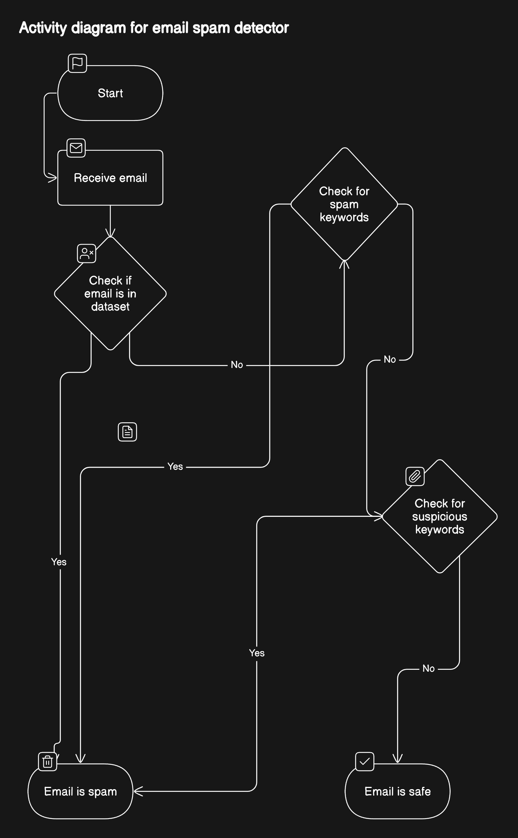

**4.4 Important Diagrams**

## 

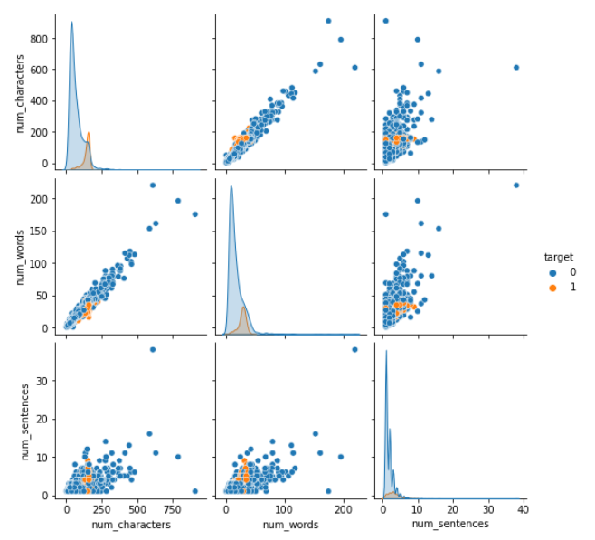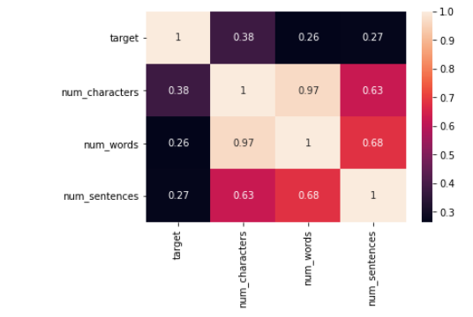

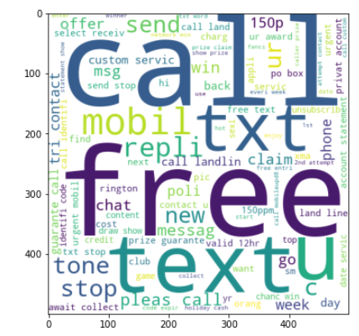\\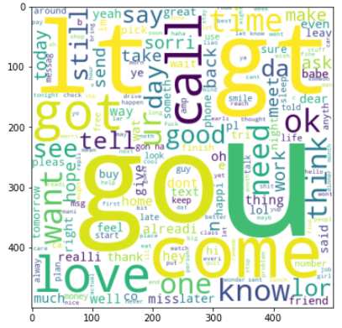

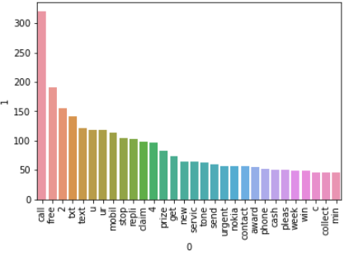

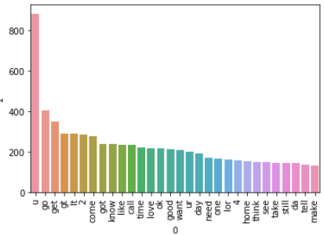

**4.6 Data Flow Diagram**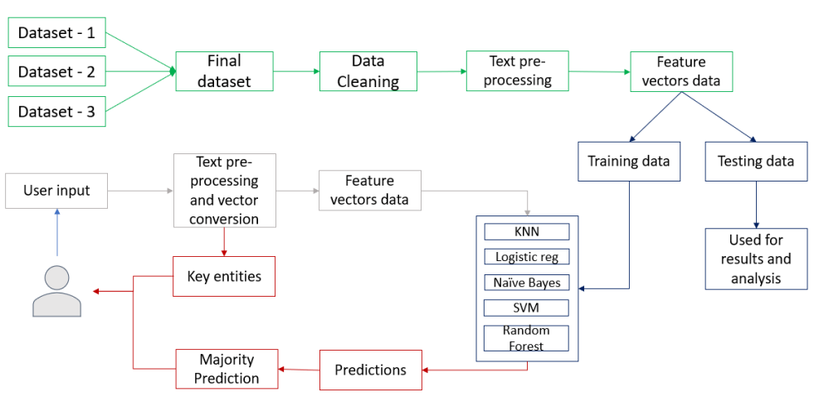

**4.8 Languages & Tools Used**

The SMS Spam Detection System leverages a robust set of languages and tools tailored for handling intricate data processing and machine learning tasks. Central to the development of this system is Python, renowned for its straightforward syntax and extensive support for data science and machine learning through libraries such as Natural Language Toolkit (NLTK) for text processing, Pandas for data manipulation, and Scikit-learn for implementing machine learning algorithms. For the user interface, Streamlit stands out as the chosen framework, enabling the rapid creation of interactive web applications directly from Python scripts. This project also incorporates Git for version control, ensuring efficient management and collaboration on the codebase. Together, these tools and languages form the backbone of the SMS Spam Detection System, facilitating the seamless integration of machine learning models into a user-friendly application.

**Chapter 5: Code Implementation**

**Chapter 6: Results**

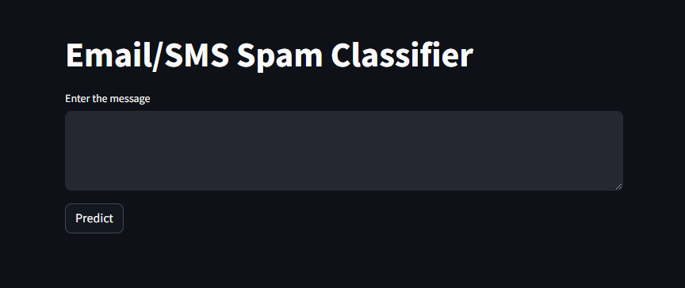

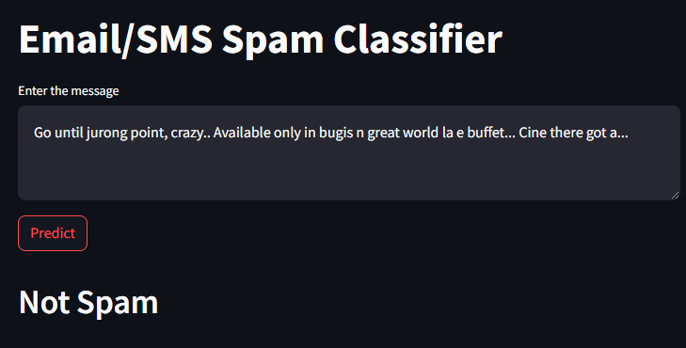

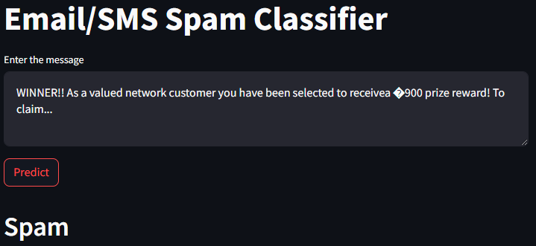

**Chapter 7: Conclusion and Future Scope**

**7.1 Conclusion:**

The SMS Spam Detection System has successfully demonstrated the efficacy of employing sophisticated machine learning algorithms and natural language processing techniques to sift through and accurately identify spam within SMS communications. This venture not only enhances user experience by safeguarding personal inboxes from unsolicited messages but also sets a precedent for applying such technologies to improve digital security.

The project's conclusion brings to light the significant strides made in detecting and mitigating spam content, yet it also opens up avenues for further exploration and development. The system's foundation on adaptable algorithms positions it well for future enhancements, including the incorporation of more advanced machine learning models like deep neural networks, which could offer even greater accuracy and efficiency in spam detection.

7.2 Future Scope:

The future scope of this project includes broadening its applicability to various messaging platforms and extending its linguistic capabilities to cater to a global audience. The prospect of integrating user feedback mechanisms more deeply into the system's learning process presents an opportunity to customize spam detection to individual user preferences and behaviors, making the system more dynamic and user-centric. Another promising direction is exploring the integration of real-time spam detection within messaging apps, providing users with instantaneous protection. Additionally, leveraging blockchain technology could enhance the security and privacy of the spam detection process, ensuring user data integrity and trust.

**Chapter 8: References**

* Python: https://www.python.org/
* Natural Language Toolkit (NLTK): https://www.nltk.org/
* Pandas: https://pandas.pydata.org/
* Scikit-learn: https://scikit-learn.org/stable/
* Streamlit: https://docs.streamlit.io/
* Git: https://git-scm.com/doc